Article

A Smart System for Continuous Sitting Posture Monitoring and Assessment

David Faith Odesola 1, Janusz Kulon 1* and, Shiny Verghese 1, Adam Partlow 2, and Colin Gibson 2

|  |
| --- |
| **Citation:** To be added by editorial staff during production.  Academic Editor: Firstname Lastname  Received: date  Revised: date  Accepted: date  Published: date    **Copyright:** © 2024 by the authors. Submitted for possible open access publication under the terms and conditions of the Creative Commons Attribution (CC BY) license (https://creativecommons.org/licenses/by/4.0/). |

1 Faculty of Computing, Engineering and Science, University of South Wales, Pontypridd, CF37 1DL, UK; 30025293@students.southwales.ac.uk; j.kulon@southwales.ac.uk; shiny.verghese@southwales.ac.uk

2 Rehabilitation Engineering Unit, Cardiff and Vale University Health Board, CF37 5TF, UK

Adam.Partlow@wales.nhs.uk; Colin.Gibson@wales.nhs.uk

* Correspondence: j.kulon@southwales.ac.uk

**Abstract: <<**TO BE FILLED>>.

**Keywords:** sitting posture classification, smart-sensing chair, machine learning, posture monitoring

1. Introduction

1.1 Background and Motivation

In this present day and age, sedentary behaviors such as prolonged sitting has become a fundamental part of one’s lifestyles, especially among office workers. These individuals most often find themselves confined to a desk, in front of a computer screen for an extended period; a pattern that has proven to be detrimental to one’s health [1,2]. According to the World Health Organization (WHO), the economic burdens attributed to sedentary behaviors is costing an estimate of around US$ 27 billion annually and is expected to reach US $300 billion by the year 2030 [3].

The adoption of an improper sitting postures such as slouching and asymmetric sitting is a contributing factor that further increases the risk of several other health issues, ultimately negatively affecting one’s quality of life. This bad habit is not just prevalent among the elderly population, but also across individuals within different age groups [4]. Such pattern over a long-term period, could thereby lead to the development of chronic health issues such as lower back pains [5] and other musculoskeletal conditions [6]. Hence, it is typically advised by doctors and healthcare professionals to consistently maintain an upright sitting posture which involves having your back in a straight position or perpendicular to the chair’s backrest. Furthermore, in addition to maintaining an upright sitting posture, it is also recommended to avoid sitting for a long period of time or minimizing the maintaining a singular posture for a long duration [7,8]. A few walking breaks also recommended after some given period.

Furthermore, to help combat this issue, various researchers have explored the use of smart sensing chair systems which can detect various sitting postures, thereby guiding the end user to adopt proper sitting habits. So far, various methods have been employed in the development of such smart sensing chair systems ranging from various classification methods, sensor placement configuration, and sensor types. A recent study by our team [9] highlighted a notable gap in the current research landscape. While a vast majority of similar studies primarily focuses on the detection of different sitting postures while achieving high classification accuracy, however this do not have a direct impact towards the end user. Enhancing the feedback mechanism will provide the end user with valuable information in regard to their sitting habits as well as actionable insight that will enable them to adopt proper sitting postures based on their individual’s needs.

1.2 Objective of the Study

The primary aim of this study is to design and develop a smart chair system which can classify different sitting postures using a machine learning model. This paper also aims to develop a comprehensive posture feedback system which captures sitting posture data and intelligently provides a score them as well as providing relevant insights back to the end-user.

2. Related Works

Over the recent years, there has been a constant rise in the amount of research studies conducted on sitting posture detection and monitoring system. This growing attention among researchers highlights this research’s potential of driving significant change by positively impacting postural habits among individuals, subsequently improving the quality of life [9]. Currently, there are 2 main categories of posture monitoring devices, which are wearable devices and non-wearable devices.

Wearable devices are systems which are fitted with sensors which must be always worn in order to capture real-time postural readings, mainly focusing on the spinal area. These sensors are typically small and are often integrated into clothing wear which must constantly have bodily contact. Due to its highly invasive nature, many individuals may find it quite uncomfortable and disruptive to their daily activities. In terms of the practicality of such systems among the general population, it is of great importance consider areas such energy consumption, portability and its non-invasiveness [10]. Inertial sensors such as IMUs (Inertial Measurement Unit) which are normally comprised of gyroscopes, accelerometers and sometimes magnetometers are popularly used to capture an individual’s bodily measurements. A gyroscope measures the angular postural velocity across all axes, accelerometers capture the rate of change in acceleration, while magnetometers measure the Earth’s magnetic field which provides information in determining the orientation. The combination of all 3 sensors creates a compressive picture of one’s current posture and bodily movement within a 3D space [11].

On the other hand, there are the non-wearable solutions which do not require an individual to wear any special clothing or device. These systems are non-invasive by nature are meant to capture postural measurements without being disruptive towards the end user in any way. Within this research field, there are various methods being employed such as the use of camera-based systems and sensor-infused sitting mats. Camera-based systems work by a having a set of cameras which meant to capture multiple reference points of the human body such as the head, shoulders and the hips. This typically functions by having one or more cameras placed at different point of view to effectively capture all the bodily points. For this to work effectively, there must be no obstruction between the camera’s view and the subject being assessed, and there must always be proper lighting available. Overall, this suggests that the viability of camera-based systems primarily depends on a properly controlled environment, making it an un-popular option among research studies [10]. Meanwhile, a more common method is the use of sensor-infused sitting mats which goes notion of having one or more sensors integrated into the backrest and the seating area of a seat. As the user seats and subtly moves about the chair, the system can both capture and identifying the different postures being adopted. Some of the commonly used sensors are pressure sensors, load cells, and flex sensors. One of the first research papers published that pioneered the idea of a smart sensing chair system was by Tan el. [12] back in 2001. They were able to classify 14 different siting postures using a (Principal Component Analysis)-based algorithm which interfaced with pressure sensor array module placed the both the back rest and the sitting area of the chair; achieving an overall accuracy ranging between 79% to 96%. Subsequently, a lot of research studies has been published primarily following a very similar approach. This research paper will be focusing on this approach and will be highlighting the common methods being used and the current research landscape within this field.

2.1 Sensor Technology

The sensor being used is one of the key components of a smart sensing chair systems, as it plays a key role in capturing one’s sitting pattern, which is then classified by a detection algorithm. As previously highlighted, among research studies, here are different sensors being used such as pressure sensors, load cells, flex sensors, and distance sensors, According to a literature review study by Odesola et al. in 2024 [9], the pressure sensor was seen as the most popular option among related studies.

Wang et al. [13] developed a smart chair system equipped with a (9x9) & (10x9) FSR pressure matrix which were used to classify up to 15 different sitting postures using the SNN (Spike Neural Networks). Tsai et al [14]. adopted a similar approach by using a textile-based pressure sensor array to classify 7 sitting postures while achieving an overall classification accuracy of 85.9%.

2.2 Posture Classification techniques

Over the years, there have been various types of classification techniques being used to classify various sitting postures; ranging from rule-based algorithms to more sophisticated deep-learning models as visualized in Figure 1.

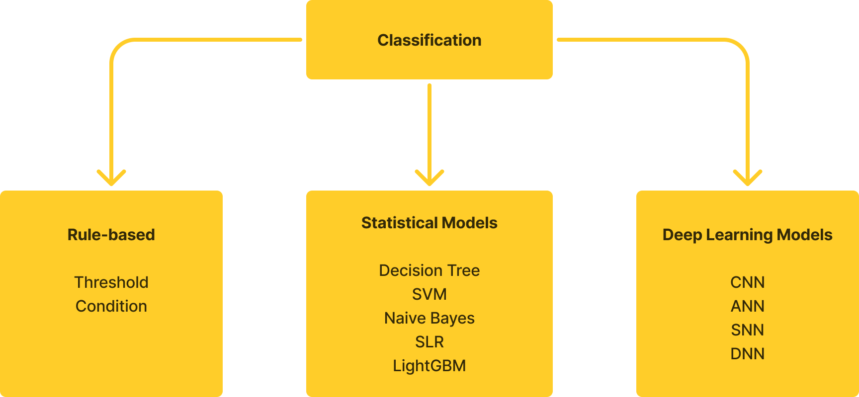

**Figure 1**. Different classification techniques being adopted

2.2.1 Rule-based techniques

Rule-based techniques are mostly built on specific rulesets and if-else conditions which are predefined in order to guide the decision making process [15]. When determining each sensor’s data threshold during the classification of different sitting posture, it is typically during the testing phase that the threshold values for each posture are identified. The main advantage of using rule-based systems is its computational simplicity and low time latency. This is mostly applicable as long as there is a limited number of defined logical rules in place. However, due to its simplicity and its rule-based nature, they are not robust and are incapable of identifying complex correlations between sitting postures [10]. There were a few studies that incorporating this technique [16,17].

2.2.2 Statistical Models

Another commonly techniques are the use of statistical models. Statistical models are based on the usage of statistical and probability methods applied on a given dataset to detect patterns and generate predictions [18]. Some of the commonly use models are K-Nearest Neighbors (KNNs) [19–22], Decision Tree [23–25], Support Vector Machines (SVMs) [14,26,27], Random Forests (RFs) [28–30].

2.2.3 Deep-Learning Models

Deep leaning models are yet another powerful method being adopted in the classification of different siting postures. Deep leaning models are defined as of neural networks which are composed of multiple hidden layers which work together provide an accurate data representation [31]. Due to its ability and robustness in detecting complex data patterns, it has been machine learning model of choice among the research studies found. Two of the most popular deep leaning models being adopted were Convolutional Neural Networks (CNNs) [32–34], and Artificial Neural Networks (ANNs) [17,35–37].

2.3 Feedback Mechanism

A well-constructed feedback mechanism is primarily aimed to both inform and encourage an individual to adopt “proper” sitting postures along with providing valuable insights that would improve their overall sitting pattern. In a given scenario, whenever a bad sitting posture is being detected for a long duration of time, the user should be alert in one way or another to correct it.

Within the current research landscape, there are multiple ways that a user could be alerted. Mobile phones have been emerging as a popular medium for collecting and displaying useful feedback back to the end user. Cai et al. [38]. developed a smart sensing chair system which relayed the detected posture via a mobile app. Additionally, Cho et al. [39] also developed a similar mobile app which provided statistical insights along with recommended YouTube videos largely based on the sitting postures being adopted. Ran et al. [35] and Ishac et al. [40] integrated haptic motors into the seating cushion which vibrated whenever an improper sitting posture is being detected which continues until an upright posture has been achieved by the individual. On the other hand, Ren et al. [41] incorporated the use of a RGB led light strip which changed in color whenever the individual needed to change their sitting posture and taking microbreaks.

Overall, it was seen that the feedback mechanism implemented among many similar studies were severely lacking mainly in providing informative elements and actionable insights. Ideally this should encourage individuals of both adopt and maintain proper sitting postures. However, most systems are more focused on simply displaying the current posture being adopted without any form of valuable feedback mechanism. While most smart-sensing systems can detect and identify various sitting postures, there are some feature sets that are absent such as real-time feedback and posture scoring mechanism which would rate and provide a score on the current posture being adopted. From the end user’s perspective, is there any certainty that the implemented feedback system has achieved its goal of inciting adopting of proper sitting postures? Furthermore, with the lack of comprehensive feedback of such systems, a lot of questions can be raised regarding both its usability and effectiveness in a real-life setting. Hence, there is a need for a comprehensive system in place to access whether the implemented feedback mechanism as achieved its desired expectations.

3. Methods and Design

3.1 Design and Requirements

This paper will be focusing on the development of smart sensing chair capable of classifying different sitting postures using a commercially available pressure sensor array. This smart sensing chair will on classifying 5 common sitting postures with are upright, slouching, leaning right, leaning left, leaning back as shown in Figure 1. Additionally, a novel feedback software application will be developed to provide valuable health insights which aims to encourage the end user to adopt proper sitting postures.

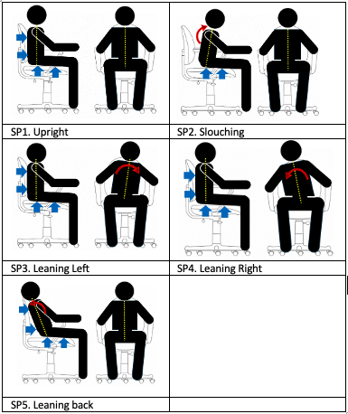

**Figure 2**. 5 different sitting postures. (**SP1**) Upright, (**SP2**) Slouching, (**SP3**) Leaning Left, (**SP4**) Leaning Right, (**SP5**) Leaning Back.

3.2 State of the Art Pressure Sensor Array

In hopes to comprehensively capture an individual’s sitting pattern, 2 CONFORMat pressure sensor arrays were installed on the chair’s backrest and seating cushion area. The CONFORMat sensor mat is a commercially available product that was developed by Tekscan [42] as shown in Figure 3. Each sensor mat is composed of 1024 pressure units, which equates to 32 units on the x-axis and 32 units on the y-axis. The value for each pressure units can range between 0 and 255. In addition to the sensor mat, there is an Evolution handle™ device which facilitate the data transfer between the sensor array and a PC computer via a tethered USB cable. A summarized technical specification list is provided in Table 1 below.



**Figure 3**. 2 (32x32) Tekscan CONFORMat Sensor along with a data acquisition module

**Table 1**. CONFORMat Sensor mat’s technical specifications [43]

|  |  |
| --- | --- |
| **Technical Specification** | **Details** |
| System Model | CER2 (CONFORMat Sensor) |
| Sensor Model | 5330 |
| Quantity | 2 |
| Sensing Area | 471.4 mm x 471.4 mm  (18.56 in. x 18.56 in.) |
| # of Sensing Elements | 2048 (1024 on each mat) |
| Pressure Range | 34 kPa (5 psi) |
| Spatial Resolution | 0.5 Sensel/cm2 (3.0 Sensels/in2) |

3.1 Experimental Setup

2 CONFORMat pressure sensor arrays were used in this experiment; one placed on the backrest and the other on the sitting cushion as shown in Figure 4 below. Each of the Evolution handle™ devices were carefully attached to the side of the chair and the linked USB cable was plugged into a Windows PC to collect the sensor data.



**Figure 4**. Office chair fitted with 2 Tekscan CONFORMat Pressure Mats.

3.2 Data Collection

In this study, only (one) individual will be participating in the experiment. The selected subject was directed to sit in 5 different sitting postures as previously highlighted in Figure 1. The subject was sat according to the 5 sitting postures for approximately 25 seconds demonstrated in Figure 4 below. During the data collection for each posture, once computer started recording the data, the subject was instructed to sit in the designated sitting position, allowing us to capture 200 frames of pressure sensor data.

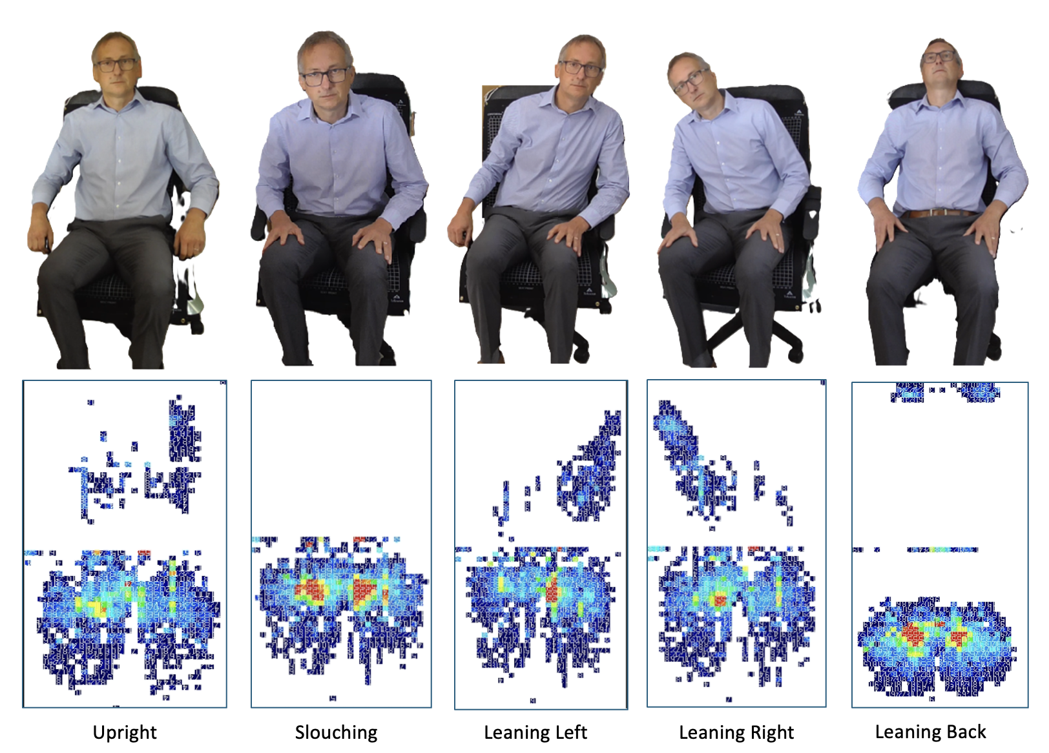

**Figure 4**. The capturing of five different sitting postures data along with its pressure distribution representation.

It must be highlighted that our data collection approach is different from similar studies as we are focused on collecting posture data from single individual rather than from a diverse set of participants with varying physical attributes. The reasoning behind this approach is that we want to train the machine learning model tailored to that specific individual. Hence, making it more precise and relevant to the user.

3.3 Machine Learning Algorithms

Multiple machine learning models were examined to determine its classification accuracy which consist of the following Naïve Bayes, Random Forest, Decision Tree, SVM, Gradient Boosting, KNN, and CNN. Each machine model was trained on the same dataset under the same conditions to ensure a fair comparison among them.

[DUPLICATED BELOW]

3.4 System Model

The entire conceptual framework of our posture monitoring system is as shown in Figure 5 below. The individual while during the experiment will be instructed to sit in various sitting posture as previously highlighted in previous section. During that period, the attached PC was used to both capture and save the sensor data along with its associated timestamp. After the data for each is posture has been thoroughly captured, we proceed with training on a series of machine learning models. Multiple machine learning models were examined to determine its classification accuracy which consist of the following Naïve Bayes, Random Forest, Decision Tree, SVM, Gradient Boosting, KNN, and CNN. Each machine model was trained on the same dataset under the same conditions to ensure a fair comparison among them. This training and the testing phase were executed using Google Colab platform.

Additionally, we constructed a web-based application that allowed us to effectively visualise the posture data and all relevant information. The web interface was programmed using the Flutter (Dart), which is an open-source framework supports multi-platform application such as iOS, Android, and Desktop under a single codebase. We also developed a backend API that used with our trained models which subsequently delivered the posture predictions in a JSON structure; This allowed our web application to easily query our its output and display the necessary graphs.



**Figure 5**. The capturing of five different sitting postures data along with its pressure distribution representation.

3.5 Posture Monitoring and Scoring System

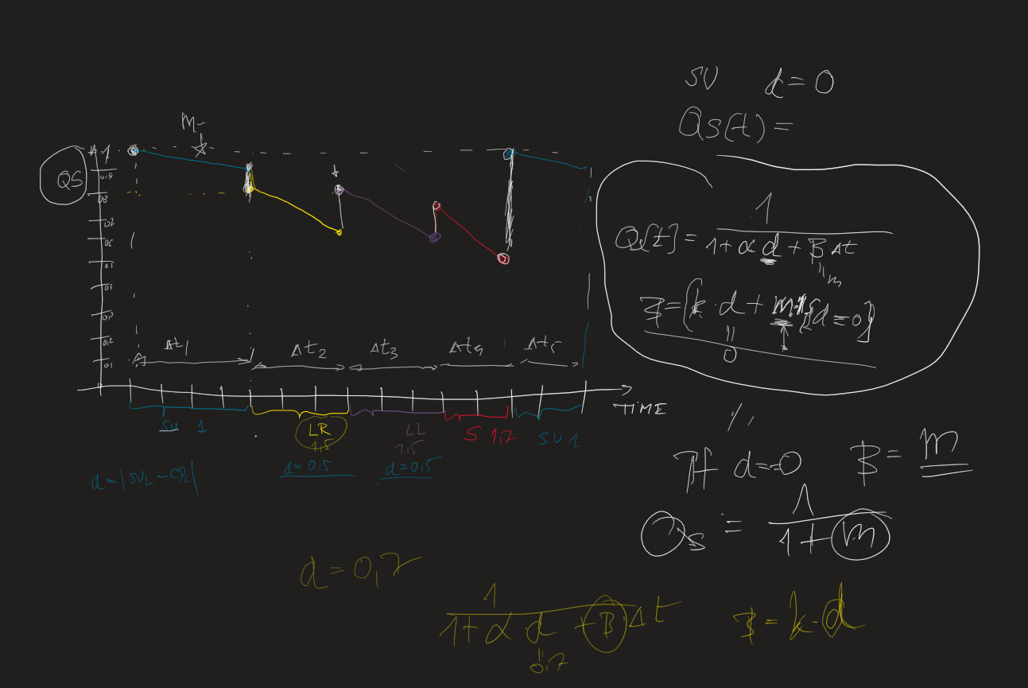

4. Results and Discussion

4.1 Performance of the Machine Learning Algorithm

In order to evaluate the accuracy of our machine learning models, 20% of the entire dataset was allocated for testing. Figure 6 below shows the confusion matrix for all the Machine Learning Models that were examined.

FIGURE: Confusion Matrix for all ML Models Here

**Figure 6**. Confusion Matrix for all of the Machine Learning Model’s results.

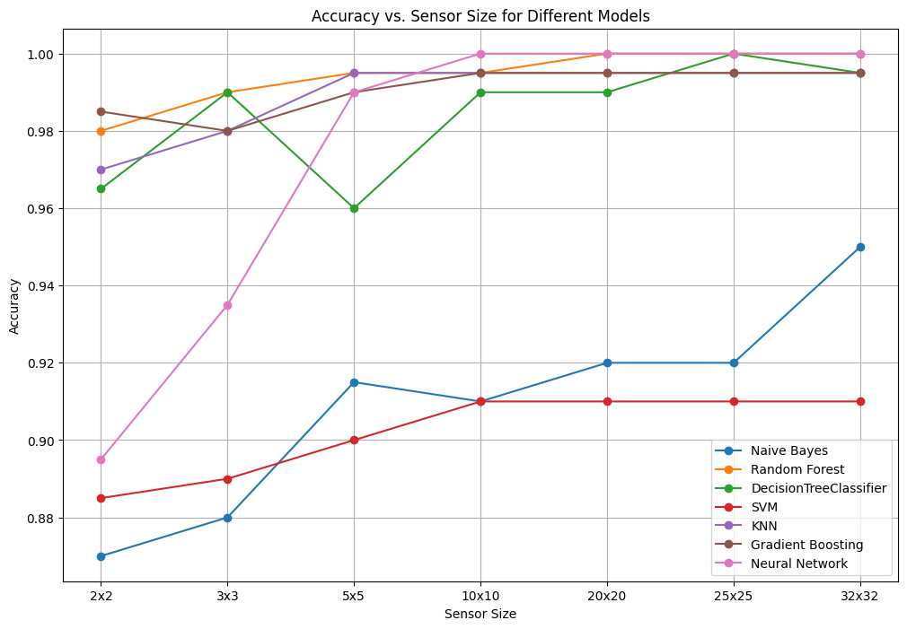

**Figure 6**. A graph comparing the accuracies of different machine learning models in respect to different sensor sizes.

4.1 Analysis of the Feedback Mechanism



**Figure 6**. First tab of the Sitting Posture Dashboard



**Figure 7**. Second tab of the Sitting Posture Dashboard

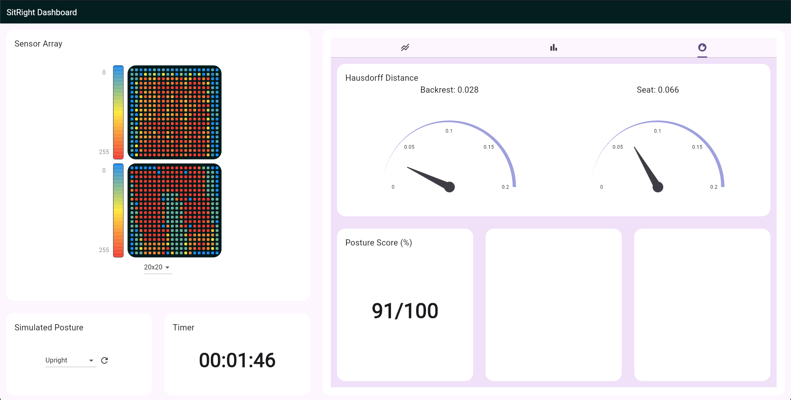

3.3 Posture Monitoring and Scoring System

3.3 Posture Monitoring and Scoring System

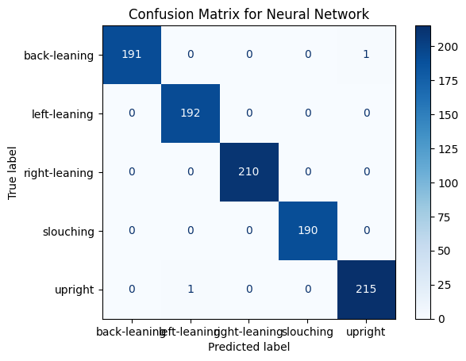

4.2 Effectiveness of the Posture Monitoring System

4.3 Statistical Analysis of Sitting Patterns

4.4 Interpretation of Results

4.5 Limitations of the Study

4. Discussion

5. Conclusions

This is the conclusion section

**Supplementary Materials:** The following supporting information can be downloaded at: www.mdpi.com/xxx/s1, Figure S1: title; Table S1: title; Video S1: title.

**Author Contributions:** <Author’s contributions>

**Funding:** This work was partly supported by the University of South Wales (USW) QR fund (ref: 104607.13.1125), RIS funding (ref: 104790.1125), and Cardiff & Vale University Health Board, Rehabilitation Engineering Unit (REU), contributions (ref: 103914.13.1122).

**Institutional Review Board Statement:** Not Applicable.

**Informed Consent Statement:** Not Applicable.

**Data Availability Statement:** We encourage all authors of articles published in MDPI journals to share their research data. In this section, please provide details regarding where data supporting reported results can be found, including links to publicly archived datasets analyzed or generated during the study. Where no new data were created, or where data is unavailable due to privacy or ethical restrictions, a statement is still required. Suggested Data Availability Statements are available in section “MDPI Research Data Policies” at https://www.mdpi.com/ethics.

**Acknowledgments:** The authors would like to thank the University of South Wales and Cardiff & Vale University Health Board, REU, for supporting the project.

**Conflicts of Interest:** The authors declare no conflicts of interest.

**Appendix A**

Appendix content

**Appendix B**

Appendix content

References

1. Daneshmandi, H.; Choobineh, A.; Ghaem, H.; Karimi, M. Adverse Effects of Prolonged Sitting Behavior on the General Health of Office Workers. *J Lifestyle Med* **2017**, *7*, 69–75, doi:10.15280/jlm.2017.7.2.69.

2. Keskin, Y. Correlation between Sitting Duration and Position and Lumbar Pain among Office Workers. *Haydarpasa Numune Med J* **2019**, doi:10.14744/hnhj.2019.04909.

3. *Global Status Report on Physical Activity 2022*; World Health Organization: Geneva, 2022; ISBN 978-92-4-005915-3.

4. Yang, L.; Lu, X.; Yan, B.; Huang, Y. Prevalence of Incorrect Posture among Children and Adolescents: Finding from a Large Population-Based Study in China. *iScience* **2020**, *23*, 101043, doi:10.1016/j.isci.2020.101043.

5. Kett, A.R.; Sichting, F.; Milani, T.L. The Effect of Sitting Posture and Postural Activity on Low Back Muscle Stiffness. *Biomechanics* **2021**, *1*, 214–224, doi:10.3390/biomechanics1020018.

6. Susilowati, I.H.; Kurniawidjaja, L.M.; Nugraha, S.; Nasri, S.M.; Pujiriani, I.; Hasiholan, B.P. The Prevalence of Bad Posture and Musculoskeletal Symptoms Originating from the Use of Gadgets as an Impact of the Work from Home Program of the University Community. *Heliyon* **2022**, *8*, e11059, doi:10.1016/j.heliyon.2022.e11059.

7. Stephens, M.; Bartley, C.A. Understanding the Association between Pressure Ulcers and Sitting in Adults What Does It Mean for Me and My Carers? Seating Guidelines for People, Carers and Health & Social Care Professionals. *Journal of Tissue Viability* **2018**, *27*, 59–73, doi:10.1016/j.jtv.2017.09.004.

8. Benatti, F.B.; Ried-Larsen, M. The Effects of Breaking up Prolonged Sitting Time: A Review of Experimental Studies. *Medicine & Science in Sports & Exercise* **2015**, *47*, 2053–2061, doi:10.1249/MSS.0000000000000654.

9. Odesola, D.F.; Kulon, J.; Verghese, S.; Partlow, A.; Gibson, C. Smart Sensing Chairs for Sitting Posture Detection, Classification, and Monitoring: A Comprehensive Review. *Sensors* **2024**, *24*, 2940, doi:10.3390/s24092940.

10. Vermander, P.; Mancisidor, A.; Cabanes, I.; Perez, N. Intelligent Systems for Sitting Posture Monitoring and Anomaly Detection: An Overview. *J NeuroEngineering Rehabil* **2024**, *21*, 28, doi:10.1186/s12984-024-01322-z.

11. Simpson, L.; Maharaj, M.M.; Mobbs, R.J. The Role of Wearables in Spinal Posture Analysis: A Systematic Review. *BMC Musculoskelet Disord* **2019**, *20*, 55, doi:10.1186/s12891-019-2430-6.

12. Tan, H.Z.; Slivovsky, L.A.; Pentland, A. A Sensing Chair Using Pressure Distribution Sensors. *IEEE/ASME Trans. Mechatron.* **2001**, *6*, 261–268, doi:10.1109/3516.951364.

13. Wang, J.; Hafidh, B.; Dong, H.; El Saddik, A. Sitting Posture Recognition Using a Spiking Neural Network. *IEEE Sensors J.* **2021**, *21*, 1779–1786, doi:10.1109/JSEN.2020.3016611.

14. Tsai, M.-C.; Chu, E.T.-H.; Lee, C.-R. An Automated Sitting Posture Recognition System Utilizing Pressure Sensors. *Sensors* **2023**, *23*, 5894, doi:10.3390/s23135894.

15. Liu, H.; Gegov, A.; Stahl, F. Categorization and Construction of Rule Based Systems. In *Engineering Applications of Neural Networks*; Mladenov, V., Jayne, C., Iliadis, L., Eds.; Communications in Computer and Information Science; Springer International Publishing: Cham, 2014; Vol. 459, pp. 183–194 ISBN 978-3-319-11070-7.

16. Matuska, S.; Paralic, M.; Hudec, R. A Smart System for Sitting Posture Detection Based on Force Sensors and Mobile Application. *Mobile Information Systems* **2020**, *2020*, 1–13, doi:10.1155/2020/6625797.

17. Martínez-Estrada, M.; Vuohijoki, T.; Poberznik, A.; Shaikh, A.; Virkki, J.; Gil, I.; Fernández-García, R. A Smart Chair to Monitor Sitting Posture by Capacitive Textile Sensors. *Materials* **2023**, *16*, 4838, doi:10.3390/ma16134838.

18. Grebovic, M.; Filipovic, L.; Katnic, I.; Vukotic, M.; Popovic, T. Machine Learning Models for Statistical Analysis. *IAJIT* **2023**, *20*, doi:10.34028/iajit/20/3A/8.

19. Pereira, L.; Plácido Da Silva, H. A Novel Smart Chair System for Posture Classification and Invisible ECG Monitoring. *Sensors* **2023**, *23*, 719, doi:10.3390/s23020719.

20. Jeong, H.; Park, W. Developing and Evaluating a Mixed Sensor Smart Chair System for Real-Time Posture Classification: Combining Pressure and Distance Sensors. *IEEE J. Biomed. Health Inform.* **2021**, *25*, 1805–1813, doi:10.1109/JBHI.2020.3030096.

21. Fragkiadakis, E.; Dalakleidi, K.V.; Nikita, K.S. Design and Development of a Sitting Posture Recognition System. In Proceedings of the 2019 41st Annual International Conference of the IEEE Engineering in Medicine and Biology Society (EMBC); IEEE: Berlin, Germany, July 2019; pp. 3364–3367.

22. Javaid, A.; Abbas, A.; Arshad, J.; Rahmani, M.K.I.; Chauhdary, S.T.; Jaffery, M.H.; Banga, A.S. Force Sensitive Resistors-Based Real-Time Posture Detection System Using Machine Learning Algorithms. *CMC* **2023**, *77*, 1795–1814, doi:10.32604/cmc.2023.044140.

23. Ma, C.; Li, W.; Gravina, R.; Fortino, G. Posture Detection Based on Smart Cushion for Wheelchair Users. *Sensors* **2017**, *17*, 719, doi:10.3390/s17040719.

24. Ma, C.; Li, W.; Gravina, R.; Du, J.; Li, Q.; Fortino, G. Smart Cushion-Based Activity Recognition: Prompting Users to Maintain a Healthy Seated Posture. *IEEE Syst. Man Cybern. Mag.* **2020**, *6*, 6–14, doi:10.1109/MSMC.2019.2962226.

25. Fu, T.; Macleod, A. IntelliChair: An Approach for Activity Detection and Prediction via Posture Analysis. In Proceedings of the 2014 International Conference on Intelligent Environments; IEEE: China, June 2014; pp. 211–213.

26. Wan, Q.; Zhao, H.; Li, J.; Xu, P. Hip Positioning and Sitting Posture Recognition Based on Human Sitting Pressure Image. *Sensors* **2021**, *21*, 426, doi:10.3390/s21020426.

27. Roh, J.; Park, H.; Lee, K.; Hyeong, J.; Kim, S.; Lee, B. Sitting Posture Monitoring System Based on a Low-Cost Load Cell Using Machine Learning. *Sensors* **2018**, *18*, 208, doi:10.3390/s18010208.

28. Feng, L.; Li, Z.; Liu, C. Are You Sitting Right?-Sitting Posture Recognition Using RF Signals. In Proceedings of the 2019 IEEE Pacific Rim Conference on Communications, Computers and Signal Processing (PACRIM); IEEE: Victoria, BC, Canada, August 2019; pp. 1–6.

29. Zemp, R.; Tanadini, M.; Plüss, S.; Schnüriger, K.; Singh, N.B.; Taylor, W.R.; Lorenzetti, S. Application of Machine Learning Approaches for Classifying Sitting Posture Based on Force and Acceleration Sensors. *BioMed Research International* **2016**, *2016*, 1–9, doi:10.1155/2016/5978489.

30. Bourahmoune, K.; Ishac, K.; Amagasa, T. Intelligent Posture Training: Machine-Learning-Powered Human Sitting Posture Recognition Based on a Pressure-Sensing IoT Cushion. *Sensors* **2022**, *22*, 5337, doi:10.3390/s22145337.

31. Alzubaidi, L.; Zhang, J.; Humaidi, A.J.; Al-Dujaili, A.; Duan, Y.; Al-Shamma, O.; Santamaría, J.; Fadhel, M.A.; Al-Amidie, M.; Farhan, L. Review of Deep Learning: Concepts, CNN Architectures, Challenges, Applications, Future Directions. *J Big Data* **2021**, *8*, 53, doi:10.1186/s40537-021-00444-8.

32. Kim, Y.; Son, Y.; Kim, W.; Jin, B.; Yun, M. Classification of Children’s Sitting Postures Using Machine Learning Algorithms. *Applied Sciences* **2018**, *8*, 1280, doi:10.3390/app8081280.

33. Fan, Z.; Hu, X.; Chen, W.-M.; Zhang, D.-W.; Ma, X. A Deep Learning Based 2-Dimensional Hip Pressure Signals Analysis Method for Sitting Posture Recognition. *Biomedical Signal Processing and Control* **2022**, *73*, 103432, doi:10.1016/j.bspc.2021.103432.

34. Chen, K. Sitting Posture Recognition Based on OpenPose. *IOP Conf. Ser.: Mater. Sci. Eng.* **2019**, *677*, 032057, doi:10.1088/1757-899X/677/3/032057.

35. Ran, X.; Wang, C.; Xiao, Y.; Gao, X.; Zhu, Z.; Chen, B. A Portable Sitting Posture Monitoring System Based on a Pressure Sensor Array and Machine Learning. *Sensors and Actuators A: Physical* **2021**, *331*, 112900, doi:10.1016/j.sna.2021.112900.

36. Luna-Perejón, F.; Montes-Sánchez, J.M.; Durán-López, L.; Vazquez-Baeza, A.; Beasley-Bohórquez, I.; Sevillano-Ramos, J.L. IoT Device for Sitting Posture Classification Using Artificial Neural Networks. *Electronics* **2021**, *10*, 1825, doi:10.3390/electronics10151825.

37. Ren, X.; Yu, B.; Lu, Y.; Zhang, B.; Hu, J.; Brombacher, A. LightSit: An Unobtrusive Health-Promoting System for Relaxation and Fitness Microbreaks at Work. *Sensors* **2019**, *19*, 2162, doi:10.3390/s19092162.

38. Cai, W.; Zhao, D.; Zhang, M.; Xu, Y.; Li, Z. Improved Self-Organizing Map-Based Unsupervised Learning Algorithm for Sitting Posture Recognition System. *Sensors* **2021**, *21*, 6246, doi:10.3390/s21186246.

39. Cho, H.; Choi, H.-J.; Lee, C.-E.; Sir, C.-W. Sitting Posture Prediction and Correction System Using Arduino-Based Chair and Deep Learning Model. In Proceedings of the 2019 IEEE 12th Conference on Service-Oriented Computing and Applications (SOCA); IEEE: Kaohsiung, Taiwan, November 2019; pp. 98–102.

40. Ishac, K.; Suzuki, K. LifeChair: A Conductive Fabric Sensor-Based Smart Cushion for Actively Shaping Sitting Posture. *Sensors* **2018**, *18*, 2261, doi:10.3390/s18072261.

41. Ren, X.; Yu, B.; Lu, Y.; Chen, Y.; Pu, P. HealthSit: Designing Posture-Based Interaction to Promote Exercise during Fitness Breaks. *International Journal of Human–Computer Interaction* **2019**, *35*, 870–885, doi:10.1080/10447318.2018.1506641.

42. Tekscan Tekscan Available online: https://www.tekscan.com (accessed on 8 October 2024).

43. Tekscan Body Pressure Measurement System (BPMS) - Research Available online: https://www.tekscan.com/products-solutions/systems/body-pressure-measurement-system-bpms-research.

**Disclaimer/Publisher’s Note:** The statements, opinions and data contained in all publications are solely those of the individual author(s) and contributor(s) and not of MDPI and/or the editor(s). MDPI and/or the editor(s) disclaim responsibility for any injury to people or property resulting from any ideas, methods, instructions or products referred to in the content.